Email template: Suggested send dates are March 16 and March 23
- Subject line: Register for WorkWell NYC’s Upcoming Webinar: Forget the Fads – Eat Your Way to Health

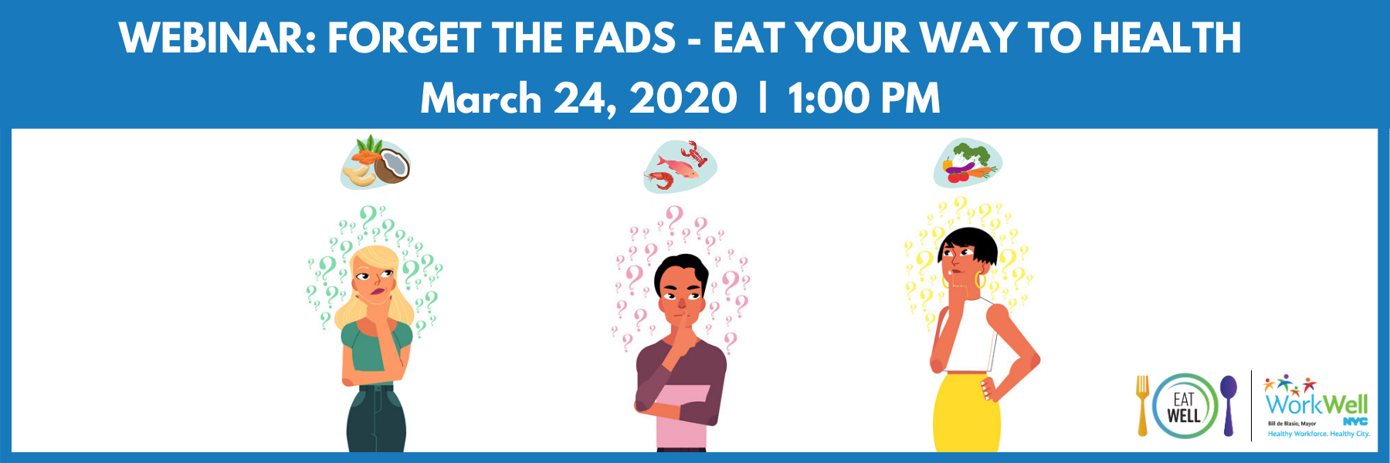
Hello insert agency employees,

Join WorkWell NYC on Wednesday, March 24th at 1:00 PM for their upcoming webinar, “Forget the Fads – How to Eat Your Way to Health”!

Participants will learn:
- How what we eat plays a major role in our health
- Which food fads to throw away and which are here to stay
- How to integrate plant-based eating towards a healthy lifestyle

Register here: bit.ly/howtoeat4health
Presenters:
Dr. Sapana Shah & Dr. Michelle McMacken
NYC Health + Hospitals/Bellevue

nyc.gov/workwellnyc
workwell@olr.nyc.gov

@workwellnyc

