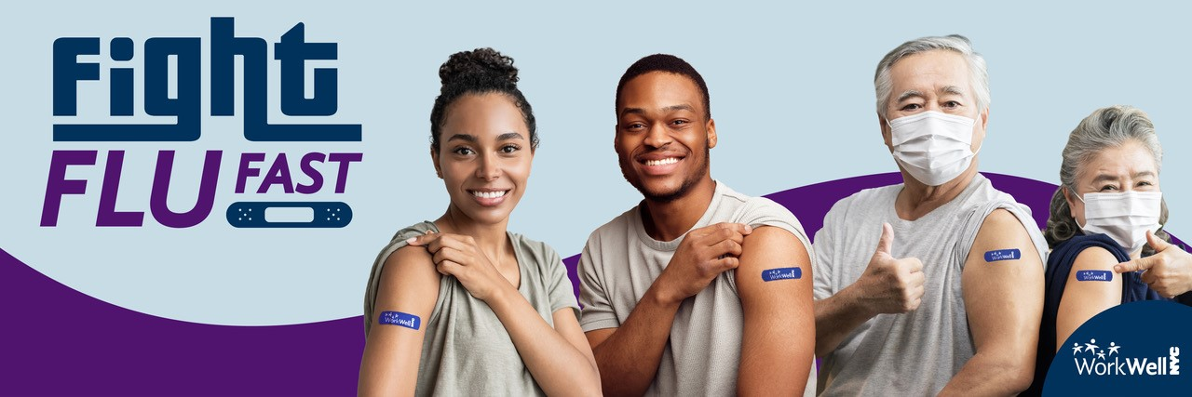

2025 Worksite Flu Clinics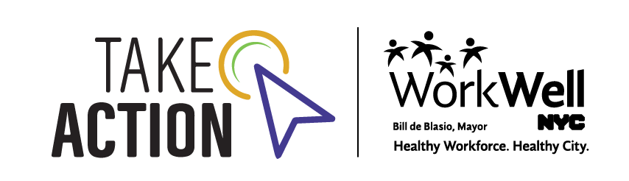 Toolkit

Introduction

Influenza - “the flu”- is a highly contagious virus that spreads easily. The flu shot is the best means of protection against the flu and its health complications. Health experts recommend that everyone aged 6 months or older get the flu vaccine each year.

As we look ahead to the fall, it is **more important than ever** toprotect our workforce against the flu.

To keep our workforce healthy, the City and its unions offer **free** flu shots to City employees, dependents, and pre-Medicare retirees eligible for New York City health benefits. Flu shots are available at worksite clinics, participating pharmacies, and in-network medical offices.

As a WorkWell NYC flu fighter, you can help employees take action to prevent the spread of this virus by setting up flu shot clinics at eligible worksites. Worksite flu clinics are a quick, convenient, and effective way to help employees stay flu-free and keep our workplaces and communities healthy. Here are some testimonials from your colleagues throughout the city who have received their vaccines through the worksite flu clinics:

*“I really appreciate how easy the worksite flu clinics make it to get vaccinated.”  
“[E]asy registration, courteous staff with positive communications skills and […] convenient locations for services.”*

*“Was useful to be able to sign up and get the flu shot at a location in my agency. Wish there were more locations open to all city employees throughout the area.”*

This guide provides step-by-step instructions to help you set up **worksite flu clinics** at your agency. There are also materials and resources to help you promote your clinics and spread the word about the importance of the flu shot.

As always, your support is critical. We are counting on you to set up worksite clinics and spread the word to your colleagues about the importance of getting vaccinated. Please don’t hesitate to reach out with any questions.

Let’s work together to provide our employees and their families with a quick, convenient, and effective way to stay flu-free and healthy this fall. Together, we can take action to help keep our City healthy.

**WorkWell NYC**

Mayor’s Office of Labor Relations

[workwell@olr.nyc.gov](mailto:workwell@olr.nyc.gov)

Safety Measures

The following procedures are in place to vaccinate employees safely at City worksites:

* Nurses will wear disposable lab coats and will change gloves with each new client.
* Each vaccination station will be disinfected after each vaccination.
* Employees should fill out their consent forms before arriving to minimize contact time. However, consent forms and pens will be available for use.
* Appointments are strongly preferred to prevent lines. All employees should make an appointment for their shot on the online scheduler and arrive at their scheduled appointment time.  Walk-ins can potentially be accommodated when possible.

To Set Up a Workplace Flu Shot Clinic:

**STEP 1: Schedule your workplace clinic**

* **Look out for your rebooking email:** If you participated in the flu program before, you should have been contacted by Affiliated Physicians to re-schedule your clinics for this year. If your clinic is already scheduled, please skip to **STEP 3**. If you have not been in touch with Affiliated Physicians, please contact Dawn Tudor at [dtudor@affiliatedphysicians.com](mailto:dtudor@affiliatedphysicians.com).
* **Select a time and place:** Clinics must be held in a well-ventilated, clean location that provides ample space for operations. Each flu shot station will require a table, two chairs, and a trash can. Please ensure there is enough space for setup, foot traffic, waiting area, etc.

WorkWell NYC is committed to making our flu clinics as accessible as possible. To determine if the location of your clinic is accessible to people with disabilities, please coordinate with your agency’s [*Disability Service Facilitator*](https://www.nyc.gov/site/mopd/resources/dsf.page) (DSF).

* **Book a new clinic**: If you have not participated in the flu program before, complete [this form](https://affiliatedphysicians.com/workwell-flu-request/) to schedule a clinic at your worksite.

**STEP 2: Confirm your clinic**

* **Confirmation:** Affiliated Physicians (AP) will send a confirmation email with the date and details for your clinic. If everything is correct, sign and return via email. 2-3 days after confirming your clinic, it will appear on the registration website: <https://apschedule.com/nycflu25>.

* **Monitoring:** You will receive access to an administrative portal to track registration from AP. Log in regularly to see how many appointments are booked. If slots book quickly, AP can extend the hours of your clinic or add more nurses – however, this requires at least 10 business days’ notice.

*If you need to contact AP about your flu clinic, please email Dawn Tudor at* [*dtudor@affiliatedphysicians.com*](mailto:dtudor@affiliatedphysicians.com)*.*

**STEP 3: Spread the word**

* **Promotional materials:** Get the word out to your colleagues! WorkWell NYC has various email and flyer templates available for use. See page 6 of this toolkit to download the promotional materials.
* **Registration website:** Share the registration link with employees so they can schedule their flu shot: <https://apschedule.com/nycflu25>. Employees who pre-register will receive a calendar invite and reminder email from AP with instructions. **Please copy the link exactly as it is shown** when sending it in a communication to staff. The **www** must be included for the link to function properly.
* **Strategies for success:** Here are some **proven tips** to help you get the word out:

***Engage leadership:*** Some commissioners are willing to send out emails of support or share pictures of themselves getting the flu shot to encourage participation. Ask your leadership team how they can support your efforts.

***Go where the people go:*** Hang posters in areas where employees are (where possible) – elevator banks, kitchens, bathrooms, common areas, etc.

***Repetition is key:*** Send reminder emails in the days and hours leading up to your event. Use our [template emails](https://www.nyc.gov/assets/olr/downloads/word/wellness/flu/fy26promotionemailtemplates.docx) designed to be sent out right before and during a flu shot clinic.

***Mix it up:*** Use multiple methods of communication spread out over several weeks: emails, flyers, intranet, TV monitors, meeting announcements, etc.

***The more, the merrier:*** Recruit wellness champions and other interested co-workers to help you spread the word. Never underestimate the power of word-of-mouth!

***Encourage pre-registration:*** Having employees pre-register ahead of time ensures that the staff has the appropriate number of vaccines for the day of the clinic and reduces wait times. Employees that pre-register will receive a calendar invite and reminder email from AP with instructions.

***Monitor the number of appointments:*** This can help you gauge interest and whether your communication strategies have been effective. If you are noticing that slots are being booked up quickly, AP can extend the hours of your clinic or add more nurses (requires at least 10 business days’ notice).

***Co-promote with the other agencies:*** If there are other agencies located in the same building or other nearby facilities, contact [other WWNYC Ambassadors](https://www.nyc.gov/site/olr/wellness/wellness-ambassador.page) at those sites and promote your flu clinics across all worksites.

***Collaborate with unions:*** Work with your labor-management committees to spread the word.

**STEP 4: Showtime**

* **Be prepared:** Make sure to **confirm the room setup** with your facilities department ahead of time. Remind your [Disability Service Facilitator](https://www.nyc.gov/site/mopd/resources/dsf.page) of the clinic if additional assistance is required.
* **Coordinate with building security:** If your clinic is open to employees outside of your building, make sure security/reception is aware and knows where to direct people. This might include having to provide the security staff with the registration list as well as letting registrants know what is required of them to enter the facility (ex: government ID, City ID, etc.)
* **Check in:** A few days before your clinic, you will receive the name of the nurses/s attending. Make sure to provide any details they will need to get into your worksite.
* **Be available:** Greet the nurse/s 1 hour before your clinic starts and bring them to the clinic location. If possible, please remain present to help ensure that your clinic runs smoothly. If you will not be onsite during the clinic, please provide AP with the contact information for someone who will be available to greet the nurses and assist with any day-of needs.

Templates and Promotional Materials

Click on the images below (while holding ctrl button on keyboard) to download.

|  |  |  |
| --- | --- | --- |
| Worksite Flu Clinic Flyer *PDF*   *Customize this flyer with your clinic information, and post in breakrooms, bathrooms, or other high traffic areas to encourage participation at your worksite flu clinic.* | Email Templates*Word Doc*   *Simply fill in the highlighted sections, copy into an email, and send! There are templates for every stage of the process, from initial announcement to reminders on the day of the clinic.* | General Promotional Flyer *PDF*   *Use this flyer to encourage employees to get the flu shot at a worksite, pharmacy, or doctor’s office. This flyer can be utilized at sites that are not hosting worksite clinics.* |
| Email Signature*Word Doc* [Flu 2022 campaign logo that reads "Fight Flu Fast"](https://www.nyc.gov/assets/olr/downloads/word/wellness/flu/flu2023emailsignature.docx)  *Add a signature to your emails to promote your flu clinic! Copy and paste the image and text from the word doc.* | Employee FAQs*PDF*   *Share this document with employees who might have questions about the flu shot and how they can get it.* | WorkWell 101 Flyer*PDF*   *Post this flyer at your clinic to inform participants of other WorkWell NYC offerings.* |
|  | | |

|  |  |  |
| --- | --- | --- |
| Social Media Image*JPEG*   *If your agency has social media channels, use these images to promote your worksite clinic. Don’t forget #workwellnyc!* | Social Media Image*JPEG*   *If your agency has social media channels, use these images to promote your worksite clinic. Don’t forget #workwellnyc!* | Social Media Image*JPEG*   *If your agency has social media channels, use these images to promote your worksite clinic. Don’t forget #workwellnyc!* |
| Social Media Image*JPEG*   *If your agency has social media channels, use these images to promote your worksite clinic. Don’t forget #workwellnyc!* | Social Media Image*JPEG*   *If your agency has social media channels, use these images to promote your worksite clinic. Don’t forget #workwellnyc!* | Social Media Image*JPEG*   *If your agency has social media channels, use these images to promote your worksite clinic. Don’t forget #workwellnyc!* |
| **Suggested Social Media Post Text**  City employees! Fight the flu FAST by getting your FREE flu shot. Here are 3 convenient ways to get your flu vaccine.   * Get Your Flu Shot at a WorkWell NYC Clinic – a quick and convenient way for City employees to stay flu-free! * Get Your Flu Shot at a Participating Pharmacy – free flu shots are available for City employees at participating pharmacies across the city. * Get Your Flu Shot from an In-Network Physician - your co-pay will be waived if getting the flu shot is the sole purpose of your visit.   For more information, visit [**on.nyc.gov/wwnycflu**](http://on.nyc.gov/wwnycflu) | | |

Orientation Materials

**Missed the Worksite Flu Clinic Ambassador Orientation?**

Click on the images below (while holding the ctrl button on the keyboard) to view the full recording and slide deck to learn tips and strategies for holding a successful worksite flu clinic.

|  |
| --- |
| Orientation Slides *Slideshow*   *Missed the Ambassador Worksite Flu Clinic Orientation session? Access the slide presentation here.* |

**Have questions about how to promote your flu clinic? WorkWell NYC is here to help!**

**Email** [**workwell@olr.nyc.gov**](mailto:workwell@olr.nyc.gov?subject=Flu%20shot%20clinics)**.**

Frequently Asked Questions

1. **Who is eligible to get a flu shot?**  
   All employees eligible for health benefits through the City can receive their flu shot at work for no cost. Employees, dependents, and pre-Medicare retirees covered by City health benefits can get flu shots free of cost at participating pharmacies or an in-network physician’s office.
2. **Is it safe to host a flu shot clinic at my worksite?**

Extensive safety measures have been put in place to ensure that workplace flu shots can be given safely. Please see “Safety Measures” on page 3 for more details. Now more than ever, everyone needs to do their part to prevent the spread of respiratory illnesses. Hosting a worksite flu shot clinic and encouraging employees to get vaccinated is one of the things you can do to help keep your worksite and our City healthy this fall.

1. **My worksite has special circumstances (i.e. unusual work schedules, employees in the field, security restrictions, etc.). Can I still host a worksite clinic?**

WorkWell NYC will try our best to accommodate your needs! Email us at [workwell@olr.nyc.gov](mailto:workwell@olr.nyc.gov) and we can work together on a plan that best serves your worksite.

1. **How many flu shots can be given at a worksite clinic?**

Worksite flu shot clinics can give 15 vaccinations per hour, and a minimum of 2 hours is required to schedule a clinic. In a typical year, you can expect approximately 30% of onsite employees to attend an at-work clinic. Working with these numbers, you can determine the number of hours needed to vaccinate your onsite workforce and decide whether you’d like to spread them out over several hours or days. **We highly recommend having at least 100 staff on site on the day of the clinic.** If registration warrants, additional staff can be added to increase capacity. Remember, these numbers are estimates and may vary based on a number of factors. WorkWell NYC can help you create the best plan for your agency/worksite.

1. **I have an employee who needs a thimerosal-free flu shot. What should I do?**

A limited number of thimerosal-free shots are available on a first come, first served basis, while supplies last.

1. **Will there be a flu shot available for people 65 and over?**

Yes, vaccines specifically designed for those 65 years and older are available upon request.

1. **Can pregnant people receive flu shots at the worksite?**

Yes, worksite flu clinics will offer flu shots to all pregnant people, regardless of trimester. Learn more [here](https://www.cdc.gov/flu/highrisk/pregnant.htm).

1. **Can people with an egg allergy receive flu shots at the worksite?**

CDC egg allergy guidance update: People with an egg allergy, regardless of the severity of past allergic reaction to egg, are now eligible to receive a flu vaccination at this event.

1. **Are worksite flu clinics private?**

While privacy screens will be provided to separate the area where shots are administered, flu clinics are in common areas of work settings where **we cannot guarantee absolute privacy**. The flu shot is given in the upper arm, so participants are encouraged to wear short sleeves.

1. **What if someone needs proof of vaccination?**

If someone would like proof of vaccination, they should email [myresults@affiliatedphysicians.com](mailto:myresults@affiliatedphysicians.com) and provide their full name, date of birth, date and location of the vaccination.

**How can my doctor confirm I received my flu shot?**Providers who are registered with The New York Citywide Immunization Registry (CIR) will have access to immunization record on individuals.  If you, yourself want to check, you can use this link [My Vaccine Record (cityofnewyork.us)](https://myvaccinerecord.cityofnewyork.us/myrecord/)

1. **Can I get a flu vaccine and a COVID-19 vaccine at the same time?**  
   Everybody should get a flu vaccine (before or during flu season) and stay up to date with COVID-19 vaccines. You can get a COVID-19 vaccine before, after, or at the same time as you receive any other vaccine, including the flu vaccine. Although COVID-19 vaccines will not be available at WorkWell NYC clinics at this time, visit [COVID-19: Vaccine - NYC Health](https://www.nyc.gov/site/doh/covid/covid-19-vaccines.page) or [Vaccines for COVID-19 | CDC](https://www.cdc.gov/covid/vaccines/?CDC_AAref_Val=https://www.cdc.gov/coronavirus/2019-ncov/vaccines/index.html) for more information.