12 DAYS OF GRATITUDE: EMAIL TEMPLATE
Suggested subject line: Join WorkWell NYC for the 12 Days of Gratitude Challenge!

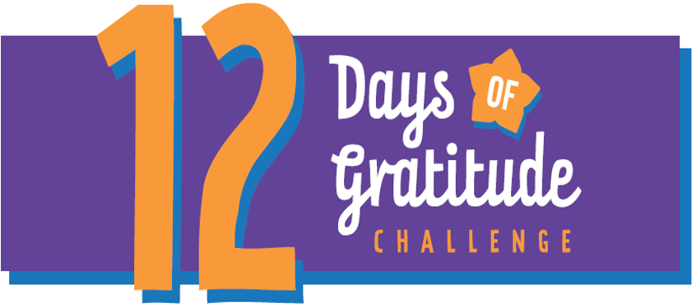

Dear [agency/worksite name] Employees:
Give yourself the gift of gratitude! Join WorkWell NYC from December 9th – 20th as we go for gratefulness together during the 12 Days of Gratitude Challenge.
Gratitude is taking time to recognize, acknowledge, and appreciate the goodness in life – no matter how big or how small. This may seem simple, but there are many health benefits associated with gratitude, like improved sleep, reduced stress, and overall well-being.
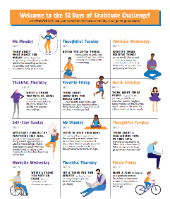
Here’s how you can participate:
- Download the challenge guide here and follow along!

- Follow @workwellnyc on Instagram for daily prompts, posts, and inspiration.

- Share what you are grateful for! Fill out this form or use the hashtag #goforgratitude on Instagram for a chance to be featured!

Questions? Contact [Site Ambassador name and email] or email workwell@olr.nyc.gov. You can also message WorkWell NYC on Instagram!

“Gratitude makes sense of our past, brings peace for today, and creates a vision for tomorrow.” – Melody Beattie
