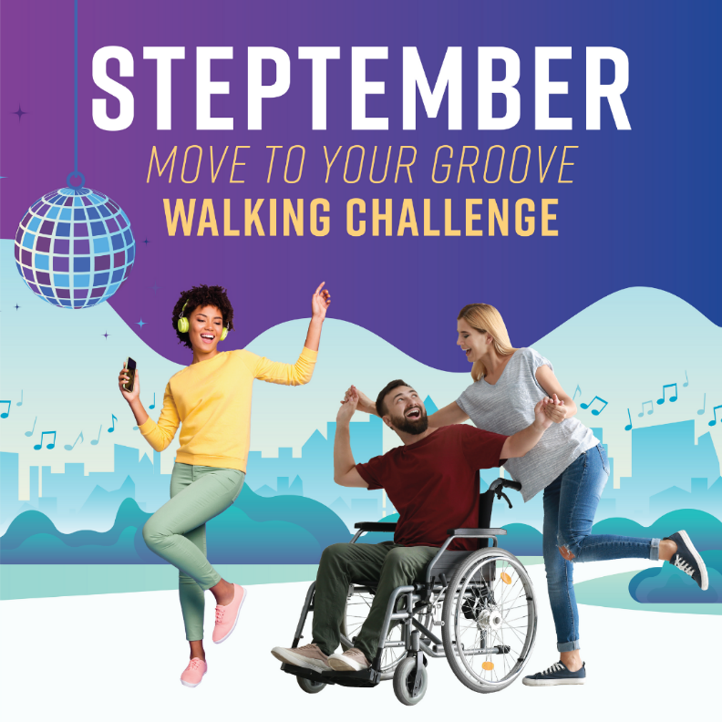

Caption:
The STEPtember Move To Your Groove Walking Challenge is here! Be a part of this musical movement and get access to exclusive playlists, dance classes, walking groups, step tips and more! Compete on a team within your agency, or as an individual. Lace up your shoes and let's get moving and grooving to the top of the leaderboard!
.
The challenge takes place from September 20th - October 19th. Register before September 15th at nyc.gov/steptember!
.
#STEPtember2021 #MoveToYourGroove #WorkWellNYC

