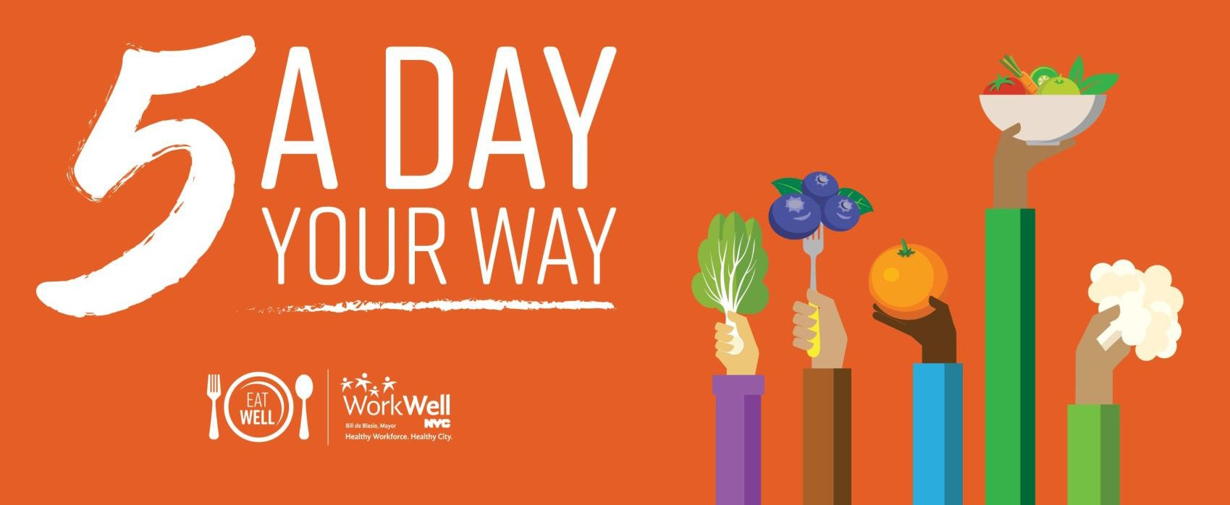

**LET’S BE THE WINNING TEAM!**

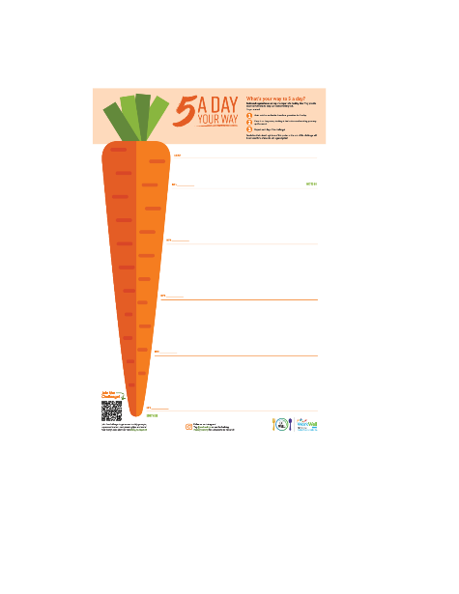WorkWell NYC challenges YOU to eat at least 5 servings of fruits and vegetables every day!

**Wednesday 3/18 – Tuesday 3/24**

# [LOCATION HERE]

Post your fruits and veggies on our agency’s poster each day of the challenge and we will be entered to **win a cooking demonstration with a professional chef**!

**Join Today!**

**Register at**

**bit.ly/5aday2020**





**Follow us on Instagram!**

Follow **@workwellnyc** and tag **#5adayyourway** for a chance to be featured!





**workwell@olr.nyc.gov**

**nyc.gov/workwellnyc**

**@workwellnyc**



**EMAIL TEMPLATES: 5 A DAY YOUR WAY**

**Email #1 | Purpose:** To announce the individual challenge

**Subject line:** WorkWell NYC: 5 A Day Your Way Challenge!

***Suggested send date:*** *March 2nd – March 6th*

|  |
| --- |
| cid:93D0351E-198B-4EBA-803C-DC4810862876@home |
| Dear [agency/worksite name] employees:  [Agency/worksite name] is celebrating National Nutrition Month with the **5 A Day Your Way Challenge** from **March 18th** – **24th**.  WorkWell NYC is challenging you to eat your way to victory by aiming for 5 servings of fruits and vegetables every day. Eating more fruits and vegetables is one of the best ways to fuel your body and your life.  Participants will receive daily email prompts, prompts, a personal tracker, healthy eating tips, and more! Plus, everyone who completes the challenge can ***enter to win*** ***a prize*** that will encourage healthy habits all year long!  **[Sign up today!](https://www.surveymonkey.com/r/5aday2020)**    Follow [**@workwellnyc**](http://www.instagram.com/workwellnyc) on Instagram for challenge information, nutrition facts, meal planning tips, and everything you will need to get ready to go for **#5ADayYourWay**.  **Questions?** Contact [Ambassador name and email], visit [**www.nyc.gov/workwellnyc**](http://www.nyc.gov/workwellnyc), or email [**workwell@olr.nyc.gov**](mailto:workwell@olr.nyc.gov). |
|  |

**Email #2 | Purpose:** to introduce 5 A Day Your Way @ Work

**Subject line:** Celebrate National Nutrition Month with [worksite]!

***Suggested send date:*** *March 9th – March 13th*

|  |
| --- |
| cid:93D0351E-198B-4EBA-803C-DC4810862876@home |
| Dear [agency/worksite name] employees:  From **Wednesday,** **March 18th to Tuesday, March 24th**, [agency/worksite] is celebrating National Nutrition Month with **5 A Day Your Way @ Work**!  Look out for the poster at [insert poster location information]. Each day, you can share how you included fruits or vegetables in your meals that day!  By participating, [Agency/worksite name] will have a chance to win an **at-work cooking demonstration by a professional chef!**  Join [agency] as we show our fruit and veggie pride. Together, we can take home the win! |
| If you haven’t already, sign up for **5 A Day Your Way** to receive daily prompts, a personal tracker, healthy eating tips, and more!  [**Sign up today!**](https://www.surveymonkey.com/r/5aday2020) |
| Follow [**@workwellnyc**](http://www.instagram.com/workwellnyc) on Instagram for challenge information, nutrition facts, meal planning tips, and everything you will need to get ready to go for **#5ADayYourWay**.  **Questions?** Contact [Ambassador name and email], visit [**www.nyc.gov/workwellnyc**](http://www.nyc.gov/workwellnyc), or email [**workwell@olr.nyc.gov**](mailto:workwell@olr.nyc.gov). |
|  |

**Email #3 | Purpose:** Promote 5 A Day Your Way @ Work

**Subject line:** 5 A Day Your Way Begins Today!

***Suggested send date:*** *March 18th*

|  |  |  |  |  |  |
| --- | --- | --- | --- | --- | --- |
| |  | | --- | | cid:93D0351E-198B-4EBA-803C-DC4810862876@home | | Dear [agency/worksite name] employees:    **5 A Day Your Way @ Work** is here!  Visit the **5 A Day Your Way @ Work** poster at [location] to share how you strive for 5 servings of fruits and vegetables. Whether you’re a fruit fanatic, vegetable lover, or still learning what you like, every serving counts!  By participating, [Agency/worksite name] will have a chance to win an **at-work cooking demonstration** by a professional chef! | | If you haven’t already, sign up for **5 A Day Your Way** to receive daily prompts, a personal tracker, healthy eating tips, and more!  [**Sign up today!**](https://www.surveymonkey.com/r/5aday2020) | | Follow [**@workwellnyc**](http://www.instagram.com/workwellnyc) on Instagram for challenge information, nutrition facts, meal planning tips, and everything you will need to get ready to go for **#5ADayYourWay**.  **Questions?** Contact [Ambassador name and email], visit [**www.nyc.gov/workwellnyc**](http://www.nyc.gov/workwellnyc), or email [**workwell@olr.nyc.gov**](mailto:workwell@olr.nyc.gov). | |  | |

**Email #4 | Purpose:** 5 A Day Your Way @ Work reminder

**Subject line:** How do you veggie?

***Suggested send date:*** *March 20th – March 23rd*

|  |
| --- |
| cid:93D0351E-198B-4EBA-803C-DC4810862876@home |
| Dear [agency/worksite name] employees:    **5 A Day Your Way @ Work** is underway!  Don’t forget to visit the poster at [location] and share how you strive for 5 servings of fruits and vegetables each day.  Your participation could help [agency/worksite name] win **an at-work cooking demonstration by a professional chef!**    Follow [**@workwellnyc**](http://www.instagram.com/workwellnyc) on Instagram for challenge information, nutrition facts, meal planning tips, and everything you need to go for **#5ADayYourWay**.  **Questions?** Contact [Ambassador name and email], visit [**www.nyc.gov/workwellnyc**](http://www.nyc.gov/workwellnyc), or email [**workwell@olr.nyc.gov**](mailto:workwell@olr.nyc.gov). |
|  |