Suggested Instagram Post:

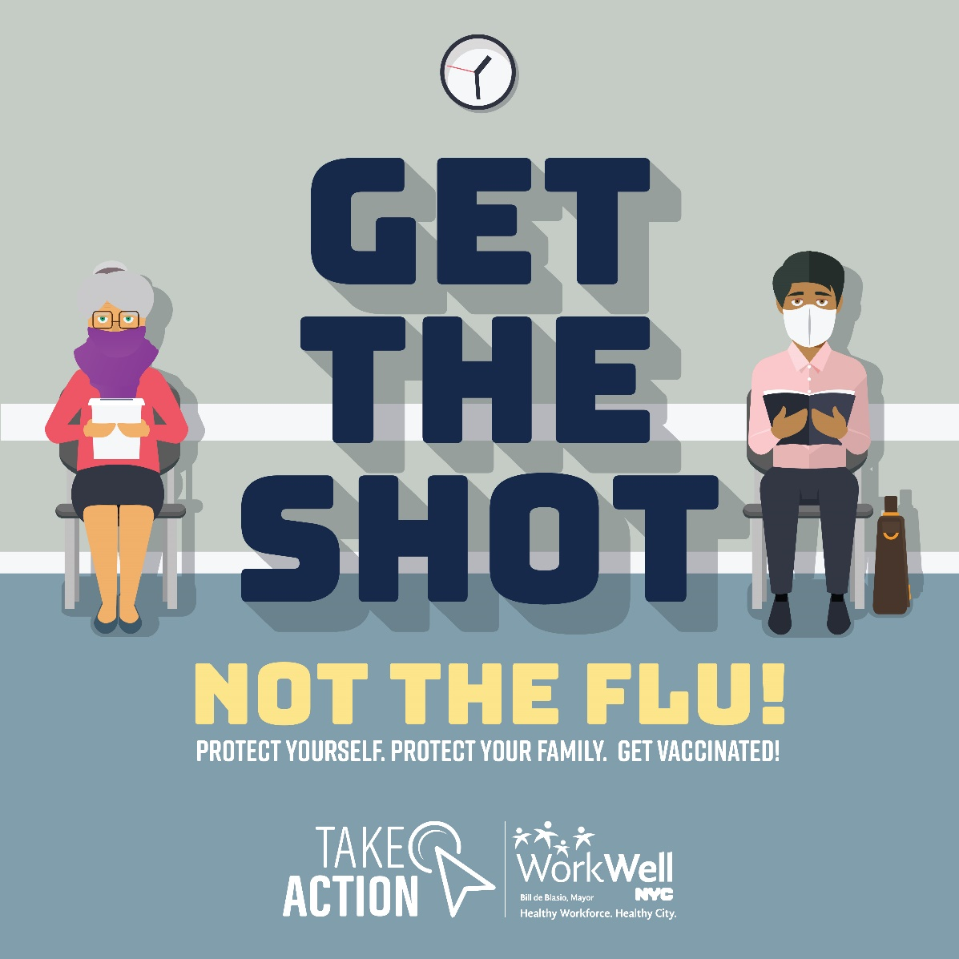

Suggested Caption:

Do Your Part During the COVID-19 Pandemic: Get Your Flu Shot
This year’s flu vaccine could be the most important one you ever get. Now more than ever, everyone needs to do their part to prevent the spread of flu and COVID-19. Getting a flu shot is the best way to protect yourself, your loved ones and your community. Visit on.nyc.gov/wwnycflu to learn more about flu clinics at City worksites and in your neighborhood.

