# ARE YOU UP FOR A CHALLENGE?

WorkWell NYC challenges you to eat at least 5 servings of fruits and vegetables every day! Have some veggie fun with WorkWell NYC and enter for a chance to win the **Eat Well prize pack**!

# Challenge Begins: March 18th Challenge Ends: March 24th Register Online: bit.ly/5aday2020

**Scan me with your smartphone**

**Follow us on Instagram!**

Follow **@workwellnyc** and tag **#5adayyourway** for a chance to be featured!

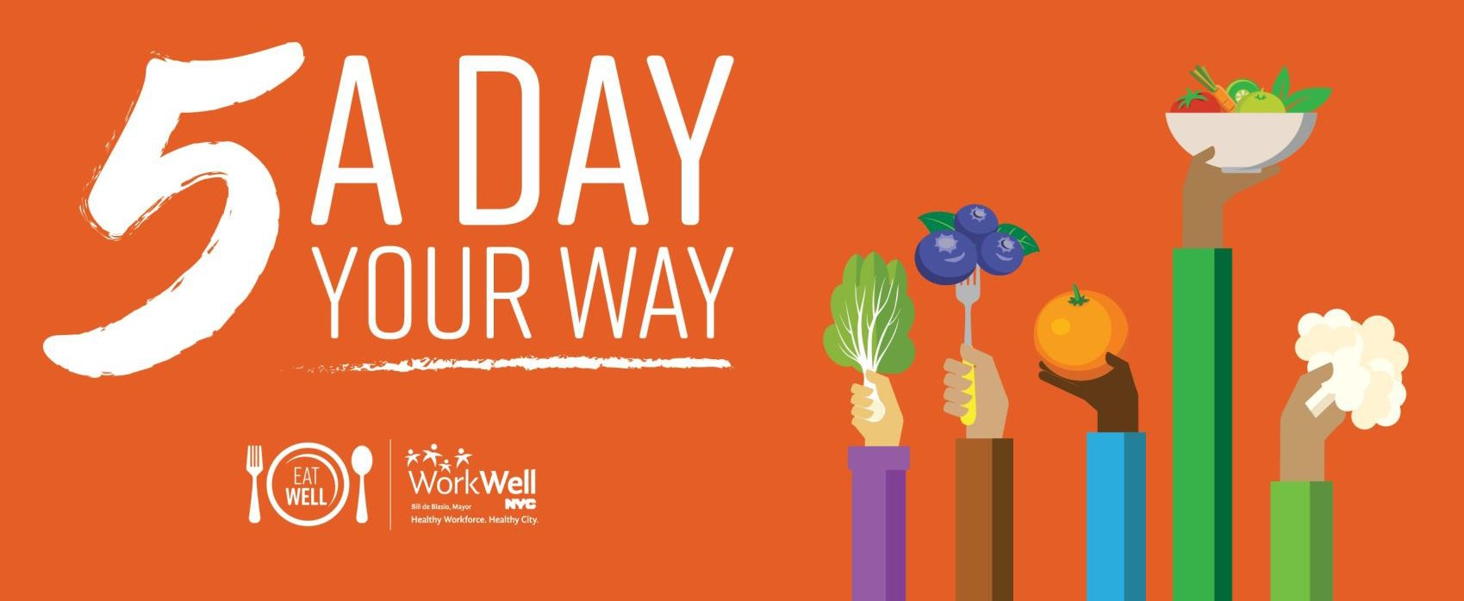[**workwell@olr.nyc.gov**](mailto:workwell@olr.nyc.gov)



[**nyc.gov/workwellnyc**](http://www.nyc.gov/workwellnyc)

**@workwellnyc**

**Email #1 | Purpose:** To announce the individual challenge

**Subject line:** WorkWell NYC: 5 A Day Your Way Challenge!

***Suggested send date:*** *March 2nd – March 6th*

|  |
| --- |
| cid:93D0351E-198B-4EBA-803C-DC4810862876@home |
| Dear [agency/worksite name] employees:  [Agency/worksite name] is celebrating National Nutrition Month with the **5 A Day Your Way Challenge** from **March 18th** – **24th**.  WorkWell NYC is challenging you to eat your way to victory by aiming for 5 servings of fruits and vegetables every day. Eating more fruits and vegetables is one of the best ways to fuel your body and your life.  Participants will receive daily email prompts, prompts, a personal tracker, healthy eating tips, and more! Plus, everyone who completes the challenge can ***enter to win*** ***a prize*** that will encourage healthy habits all year long!  [**Sign up today!**](https://www.surveymonkey.com/r/5aday2020)    Follow [**@workwellnyc**](http://www.instagram.com/workwellnyc) on Instagram for challenge information, nutrition facts, meal planning tips, and everything you will need to get ready to go for **#5ADayYourWay**.  **Questions?** Contact [Ambassador name and email], visit [**www.nyc.gov/workwellnyc**](http://www.nyc.gov/workwellnyc), or email [**workwell@olr.nyc.gov**](mailto:workwell@olr.nyc.gov). |
|  |