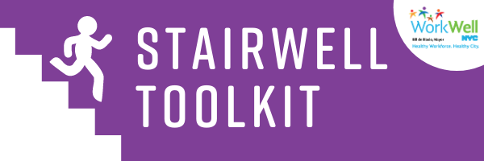

Promote Stair Use at Your Worksite

Introduction 2
Using This Toolkit 2
How To Promote Stair Use 3
Steps To Stay Safe 4
Resources 4
Email Templates 5
Stair Prompt Signage 7

workwell@olr.nyc.gov | nyc.gov/workwellnyc | @workwellnyc

Introduction

Taking the stairs is a simple, convenient way to increase daily physical activity levels! Regular stair can positively impact daily wellbeing and long-term wellness. Health benefits of stair use include improved muscle strength, cardiovascular benefits, weight control, and reduced risk of stroke. Plus, using the stairs is a quick way to stay physically active during the day!
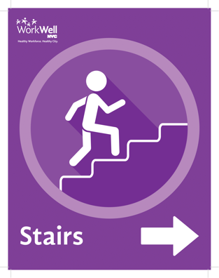
As employees transition back to the worksite, stair use is recommended as an alternative to elevators to allow for social distancing and to reduce crowding.

WorkWell NYC has created stair prompt signage that you can hang at your worksite to encourage stair use. This toolkit is designed to guide you through the process of assessing your worksite’s stairwells and hanging up stair prompts – one step at a time!

Using This Toolkit

This toolkit contains:
- Information on evaluating stairwells for use
- A step-by-step guide for promoting stair use at your agency/worksite
- Stair prompts that can be placed near stairwells and elevators
- Email templates to encourage your co-workers to take the stairs

How To Promote Stair Use

Take it one step at a time! Follow the steps outlined below to promote stair use at your worksite.

- Assess stairwell condition. First, it is important to know if the stairs in your site are currently open and how accessible they are to employees. Find out:
- Is the stairwell well-marked? Is it easily accessible for people to use?
- Is the stairwell well-lit and bright enough to make people safe and comfortable?
- Are the stairs well-maintained and free of debris? Are railings, landings, and stairs in good condition? Are they cleaned regularly?
- Get permission from your leadership and facilities/maintenance team to hang stair prompts. Determine if your building is owned by the City or leased – if it is leased, the landlord may have their own requirements/policies on stair use.
- Find the most strategic and effective location to place stair prompts. Place them at eye level in locations where they will be noticeable, such as about 4 inches above the elevator call button, on the door to the stairwell, and/or in commonly used hallways.
- Place your prompts. You may want to frame or laminate your stair prompts to keep them clean. Frames can be stuck to walls with double sided Velcro. WorkWell NYC has a limited number of 8.5”x11” printed stair prompt placards available. Email workwell@olr.nyc.gov to request one.
- Utilize WorkWell NYC ambassadors and champions to help spread the word about the benefits of using the stairs. Not sure if there are ambassadors or champions at your worksite? Email us at workwell@olr.nyc.gov to find out.
- Send an interoffice email to encourage co-workers to use the stairs safely. You can find email templates in this document to send to your colleagues.

Steps To Stay Safe

Here are some considerations to keep in mind when using or promoting stair use:
- Anyone who is unsure if stair use is right for them should consult with their doctor before making any kind of physical activity program shift or start.
- Handrails and railings should be used. Cover fingers with a cloth or glove when using handrails.
- Keep your eyes focused on the stairs and go one step at a time.
- Avoid congregating or having conversations on stairs, landings, or near doors.
- Maintain social distancing of 6 feet in stairwells. If you notice someone coming in the opposite direction, wait to let one person use the stairs at one time.
- Wash hands with soap and water or use hand sanitizer after each trip up or down the stairs.

Resources

CDC Guidance
cdc.gov/coronavirus/2019-ncov/daily-life-coping/personal-social-activities.html
cdc.gov/physicalactivity/activepeoplehealthynation/strategies-to-increase-physical-activity/stairwell-project-checklist.html
StairWELL Toolkit
foodfitphilly.org/wp-content/uploads/2016/12/GHP_StairWELL_Toolkit_FINAL.pdf
Taking the Stairs Guide
www.publichealth.hscni.net/sites/default/files/Taking_the_stairs_guide%20final.pdf
StairWELL to Health
institute.welcoa.org/wp/wp-content/uploads/2015/05/stairwell-to-health.pdf

Email Templates
Subject Line: Try this! Take the stairs

Hello [Insert agency or department name here],

Have you seen our new purple stair prompts at the office? Taking the stairs is good for your health and we encourage you to do so if you are able. In addition to helping you increase your level of physical activity, taking the stairs can help you practice social distancing at the office.
Here are some considerations for taking the stairs:
Not sure if taking the stairs is right for you? Consult your doctor before making a change to your physical activity routine.
Remember to wash your hands with soap and water or use hand sanitizer after each trip up or down.
Maintain social distancing of 6 feet in stairwells. If you notice someone coming in the opposite direction, wait to let one person use the stairs at a time.

Subject line: Building new habits – taking the stairs

Hello [Insert agency or department name here],

Have the purple stair prompts been reminding you to take the stairs? Starting new habits can be hard, but try to stick with it and build the stairs into your routine if you are able.

Climbing the stairs can help you get more active during the workday and also practice social distancing - a win-win! As a reminder, here are some things to consider when using the stairs:

Not sure if taking the stairs is right for you? Consult your doctor before making a change to your physical activity routine.
Remember to wash your hands with soap and water or use hand sanitizer after each trip up or down.
Maintain social distancing of 6 feet in stairwells. If you notice someone coming in the opposite direction, wait to let one person use the stairs at a time.

Stair Prompt Signage

WorkWell NYC has a limited number of 8.5”x11” printed stair prompt placards available. Email us at workwell@olr.nyc.gov to request stair prompt placards.
You can also find digital versions below that you can print:

 | 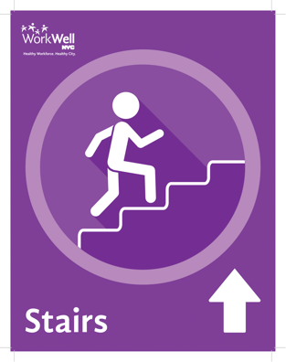 | 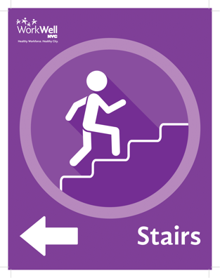

WorkWell NYC is here to support you every step of the way. Email us at workwell@olr.nyc.gov if you have any questions or need support. We also love photos! Send us pictures of how you’re using the stair prompts at your worksite.

