Email #1: Initial Announcement (suggested send date: 3-4 weeks before screening event)
Subject line: Do you know your numbers?

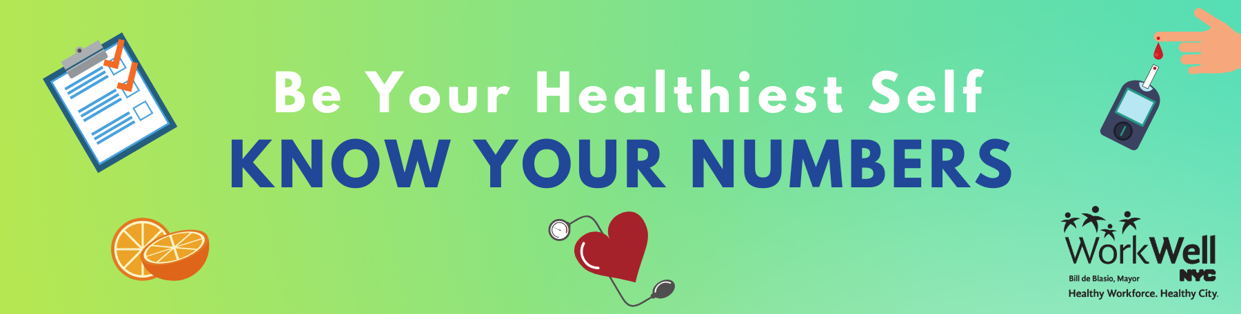
Dear [agency/worksite name] employees:

WorkWell NYC wants you to take action and know your numbers.

Knowing your numbers can help you better understand your health and if you may be at risk for heart disease, diabetes, or other health problems.

To help you know your numbers, WorkWell NYC is bringing health screenings to your worksite:

[Agency/location name]
[Date, Time]
[Location – room/address]

Come find out your blood pressure, BMI, waist circumference, and diabetes risk, and speak with a nurse about your results and what they mean for your health.

Make your appointment HERE
Username: workwell
Password: nyc

Questions? Contact [Coordinator name] at [Coordinator email/phone].
Email template #2: Second announcement (suggested send date: 1 week after initial email)
Subject line: Take action - know your numbers!

Dear [agency/worksite name] employees:

WorkWell NYC wants you to take action and know your numbers.

Knowing your numbers can help you learn more about your health and if you may be at risk for heart disease, diabetes, or other health problems.

To help you know your numbers, WorkWell NYC is bringing health screenings to your worksite:

[Agency/location name]
[Date, Time]
[Location – room/address]

Why sign up?
- It’s free!
All [agency/worksite location] employees can participate and learn their blood pressure, BMI, waist circumference, and diabetes risk at no cost.

- It’s convenient!
Just visit [location] on [date] between [start time – end time]. To save time, make an appointment for a 10-minute time slot here and print out your paperwork in advance.

- It’s important!
Knowing your numbers can help you better understand your health, and if you may be at risk for heart disease, diabetes, or other health problems. Take action – know your numbers!

Make your appointment HERE
Username: workwell
Password: nyc

Questions? Contact [Coordinator name] at [Coordinator email/phone].

