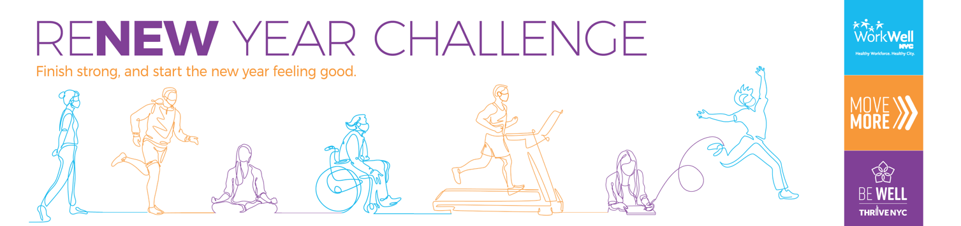

Dear [insert agency] employees,

This year brought unexpected events to our city and forced many of us to change our lifestyles and habits. While there are many things we can’t control, taking care of our minds and bodies is essential to staying healthy and positive, even during challenging times.

Are you ready to reflect, reset, reboot, and start the new year feeling refreshed and restored? Join the ReNew Year Challenge - a 15-day mind-body challenge hosted by WorkWell NYC.

ReNew Year challenges you to do one thing each day for your mind and your body:
MIND: Each day will include an activity that will help you reflect on the past year with gratitude, focus on the present with mindfulness, and look forward to the next year with positivity.
BODY: Choose your level – are you a Goal Getter, a Holiday Hustler, or ready to Sleigh All Day? Aim to reach 6,000, 8,000 or 10,000+ steps each day of the challenge.

The challenge begins on December 7 – are you in?
Join [insert agency] in committing to your physical and mental health and finishing the year on a positive note. Visit on.nyc.gov/renewyear to register and download the Challenge FAQs for more information.
nyc.gov/workwellnyc | workwell@olr.nyc.gov | @workwellnyc | linkedin.com/company/wwnyc

