STEPtember 2020 Instagram Post
Suggested post date: September 1st – 9th

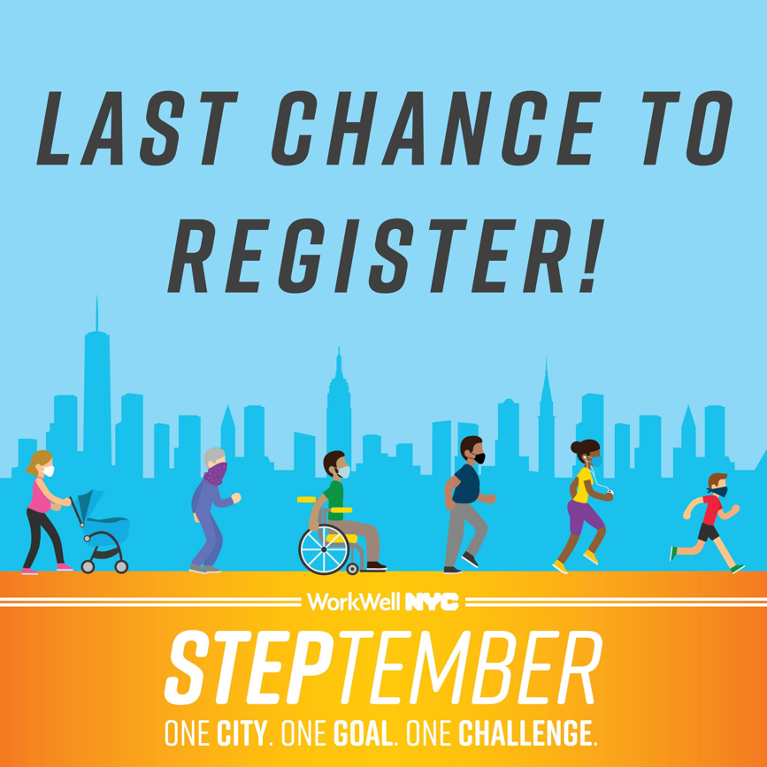

Caption:
Last chance! The STEPtember challenge begins on Monday, September 14th. Register now at nyc.gov/steptember and join a team with your agency or participate individually. The virtual journey through the 5 boroughs is about to begin – so what are you waiting for?!

#steptember2020 #movemore #workwellnyc

