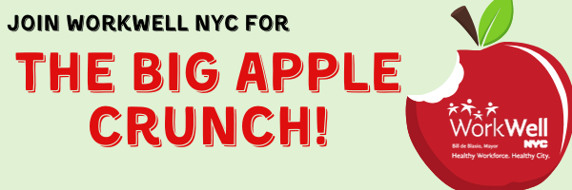
Dear [Agency Employees],

Join [Agency] and New Yorkers across the state for the Big Apple Crunch!

We will gather together to take a “collective crunch” into fresh, local apples at the same time and celebrate farm-fresh fruits and vegetables.

When:
Time:
Location:

[Please BYO apples] OR [there will be apples for everyone to enjoy!]

For more information please contact [Ambassador name] at [Ambassador phone/email].

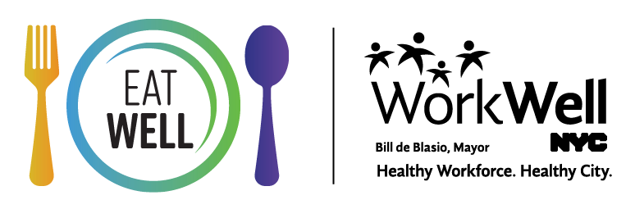
nyc.gov/workwellnyc | workwell@olr.nyc.gov

