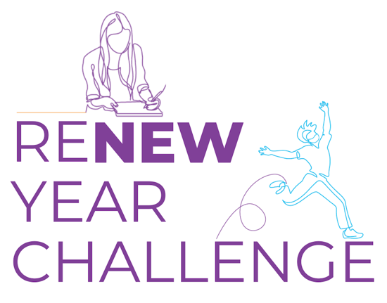 | Finish strong, and start the new year feeling good.  Reflect, reset, and reboot for the new year ahead with a 15-day mind-body challenge beginning December 7th.  Register at on.nyc.gov/renewyear.

