ReNew Year Instagram Post
Suggested post date: November 18th – December 4th

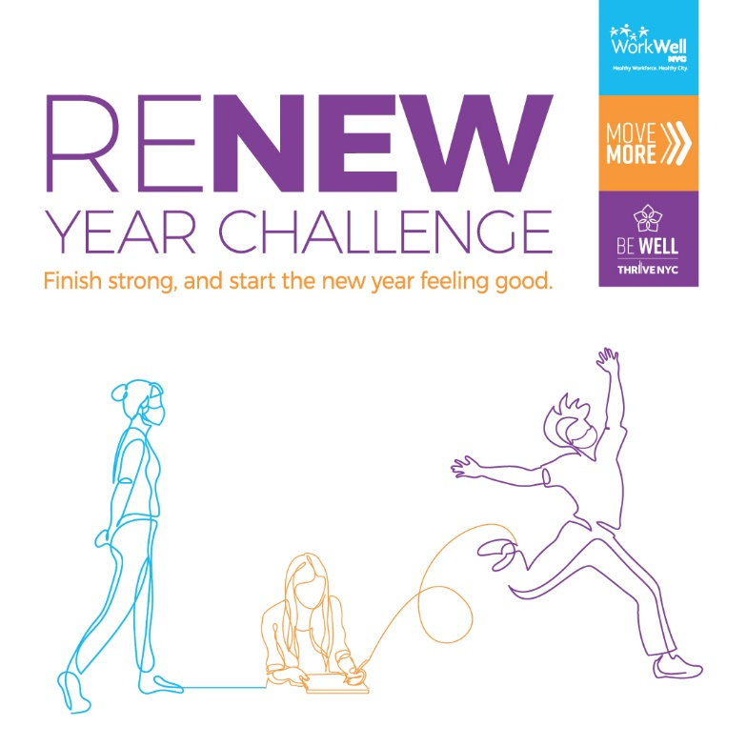

Caption:
This year brought many unexpected events into our lives. While there are many things we can’t control, taking care of our mind and body are important ways to stay healthy.

Join the ReNew Year Challenge: a 15 day mind-body challenge to help you reflect on lessons learned and achievements of 2020, get grounded into the present through mindfulness, and look ahead to the New Year with ease, positivity, and opportunities for growth.

The challenge runs December 7th-December 21st. Register at on.nyc.gov/renewyear.

