Suggested subject line: Sign the Let’s Talk! Pledge
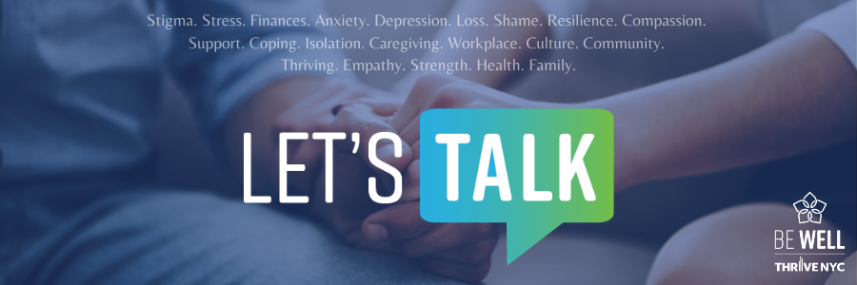
Dear [agency/worksite name] employees:

Approximately 1 in 5 New Yorkers experience a mental health disorder each year – and if you’re one of them, we want you to know that you’re not alone. [Agency/worksite name] and WorkWell NYC are committed to supporting employee mental well-being in the workplace and beyond.

We all have a part to play to help create a stigma-free work environment. Demonstrate your commitment by signing the Let’s Talk! Pledge to become a Mental Health Champion.

By signing the pledge, you commit to:
- Recognize that mental health is an important component of our overall health and well-being
- Make mental health a priority in the workplace
- Reach out to and support your colleagues
- Speak out against mental health stigma

Please share this email and invite your co-workers to sign the pledge as well. The agency with the highest percentage of Mental Health Champions at the end of 2020 will be invited to participate in a special vision board workshop to kick off 2021!
Each of us can take active steps to create more inclusive, supportive work environments by building awareness, encouraging culture change, and supporting each other. To learn more, visit nyc.gov/bewell or email workwell@olr.nyc.gov.

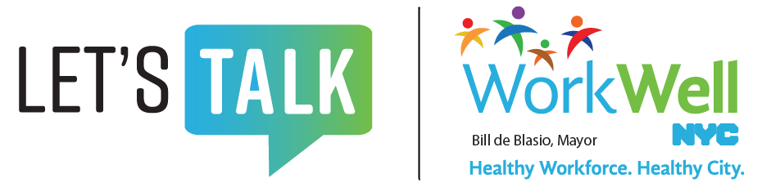

nyc.gov/workwellnyc | workwell@olr.nyc.gov | @workwellnyc

