STEPtember 2020 Instagram Post
Suggested post date: August 17th – August 28th

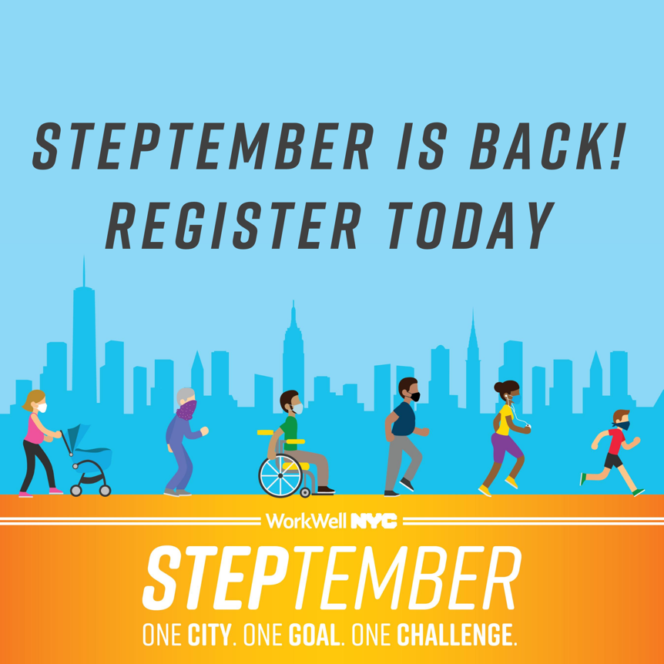

Caption:
WorkWell NYC is back for STEPtember 2020 – a month-long step challenge exclusively for City employees. This year, we’re walking, running, and rolling on a journey through the 5 boroughs, so lace up your sneakers and get ready for some friendly competition! Participate on a team with your agency or challenge yourself individually. Registration is open now through September 13th. Register today at nyc.gov/steptember.

#steptember2020 #movemore #workwellnyc

